**Order Management**

**Objective:**

The Order Management application caters to supply chain companies where they need a tracking system of their business.

**Approach:**

I have followed the API led connectivity approach where each and individual business component is exposed as micro services which can be communicated using a REST call with json format.

For this exercise I have created a domain project **order-mgmt-domain** which later can be replaced with a API-Gateway where all the requests to the application will first hit this service and which in turn would route the requests to respective micro services exposed by the application and which are under this domain project.

For this exercise I have create a business component microservice **customer-details** which uses the **order-mgmt-domain** as the domain project and serves three operations.

1. Fetch all the Customers Details (GET request)
2. Fetch a single Customer Details (GET request)
3. Insert a new Customer Details and send an Email notification (POST request)

**Technology Components Used:**

Created RAML for defining the API and doing the schematic validation of the request and response.

Used Anypoint Studio to design and develop the application and Mule runtime for the deployment of the application.

Created Mongo DB database to store the Customer Details collection in the database.

Used the GMAIL connector to send the email notifications.

Created Munit for testing the solution and enable continuous testing of the solution in the pipeline.

Defined properties file to load the environment specific configuration for the external connectors used in the solution. Based on the **mule.env** property the respective configuration file containing the details for the mongodb and SMTP connection details will be loaded.

Defined the Global exception strategy to handle the exception scenario and send a meaningful message and also to handle the rollback strategy.

Used the Java component to form the GMAIL message which needs to be sent using GMAIL connector.

Used the mavenized approach for the project

**Project Structure:**

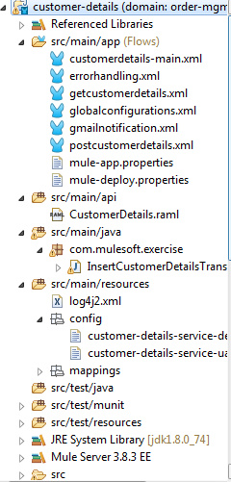

**Sample request body for POST operation:**

{

"customerName" : "Mulesoft Inc",

"customerEmail" : "contactus@mulesoft.com",

"customerContact" : "+447438992726",

"customerAddress":"Flat 31,48 East Street",

"industry" : "IT Applications"

}

**Sample response body for POST operation:**

{

“customerId” :”22443fssd111C”

}